

Semester 1 Examination 2011

Question/Answer Booklet

MATHEMATICS 3C/3D

Section Two

(Calculator Assumed) Student Number

Name Solutions

Time allowed for this section
Reading time before commencing work: 10 minutes
Working time for paper: 100 minutes

Material required/recommended for this section

To be provided by the supervisor
Question/answer booklet for Section Two.
Formula sheet.

To be provided by the candidate
Standard items: pens, pencils, pencil sharpener, highlighter, eraser, ruler.
Special items: drawing instruments, templates, notes on up to two unfolded sheets of A4 paper, and up to three calculators, CAS, graphic or scientific, which satisfy the conditions set by the Curriculum Council for this course.

Important note to candidates
No other items may be taken into the examination room. It is your responsibility to ensure that you do not have any unauthorised notes or other items of a non-personal nature in the examination room. If you have any unauthorised material with you, hand it to the supervisor before reading any further.

Structure of this examination

 | Number of questions | Working time (minutes) | Marks available
Section One  Calculator Free | 6 | 50 | 40
This Section (Section 2)  Calculator Assumed | 12 | 100 | 80
Total marks |  |  | 120

Instructions to candidates

- The rules for the conduct of WACE external examinations are detailed in the booklet WACE Examinations Handbook. Sitting this examination implies that you agree to abide by these rules.

- Answer the questions in the spaces provided.

- Spare answer pages are provided at the end of this booklet. If you need to use them, indicate in the original answer space where the answer is continued i.e. give the page number.

- Show all working clearly. Any question, or part question, worth more than 2 marks requires valid working or justification to receive full marks. If you repeat an answer to any question, ensure that you cancel the answer you do not wish to have marked.

Section Two: Calculator-assumed (80 Marks)
This section has twelve (12) questions. Answer all questions. Write your answers in the space provided.
Spare pages are included at the end of this booklet. They can be used for planning your responses and/or as additional space if required to continue an answer.
  - Planning: If you use the spare pages for planning, indicate this clearly at the top of the page.
  - Continuing an answer: If you need to use the space to continue an answer, indicate in the original answer space where the answer is continued, i.e. give the page number. Fill in the number of the question(s) that you are continuing to answer at the top of the page.

Suggested working time for this section is 100 minutes.

Question 9 (5 marks)
Perth Modern School decides to form a committee of 6 people to edit the school magazine. 9 girls and 6 boys apply, and the school decides to appoint 4 girls and 2 boys.
(a) How many different committees can be formed? [3]

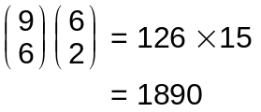



(b) Two of the girls who applied are the twins Brooke and Ailsa. Assuming that all possible committees have the same probability of being formed, what is the probability that both Brooke and Ailsa are selected? [2]
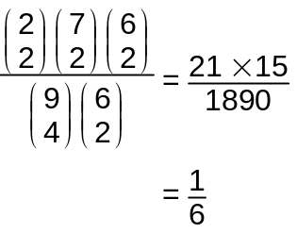



Question 10 (5 marks)
Calculate the area between the two functions 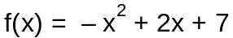 and 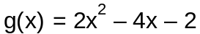 using calculus techniques.

From Classpad the graphs intersect at x = 3 and x = -1
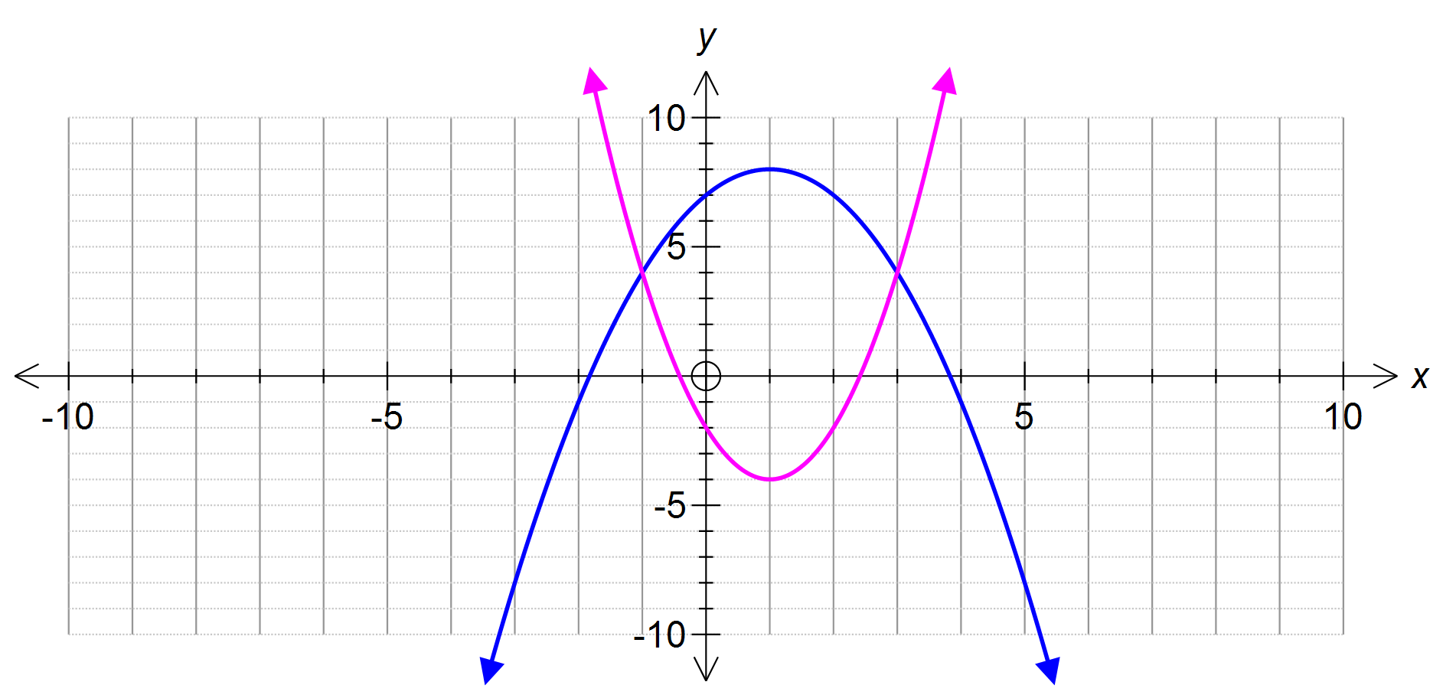


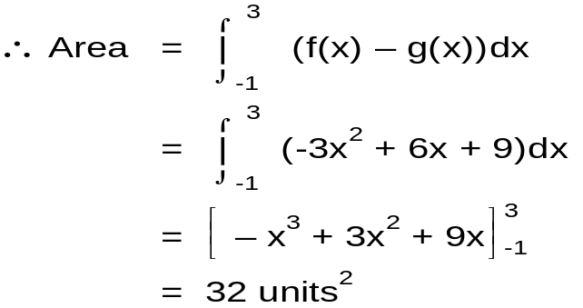





Question 11 (7 marks)
An open water tank has a square base of x metres and a height of h metres.
The total surface area of sheet metal used for its construction is 27 metres².

h
x
(a) Find an expression for h in terms of x. [2]
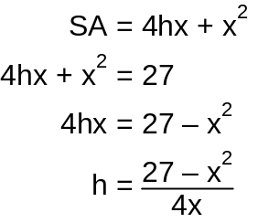


(b) Show that the volume, V, of the tank equals 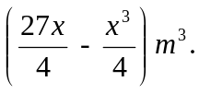 [2] 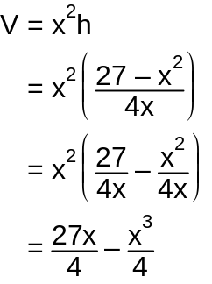


(c) Hence calculate the maximum volume possible for this tank using calculus techniques. [3]
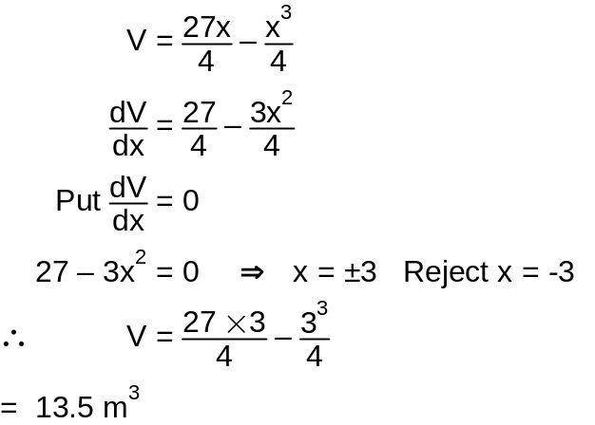




Question 12 (3 marks)
In an array of dots, there are 7 in the top row and 10 in the bottom row:

• • • • • • •

• • • • • • • • • •

Triangles are formed by selecting 3 dots as vertices, 2 in the top row and 1 in the bottom row, or vice versa.
How many different triangles are possible?
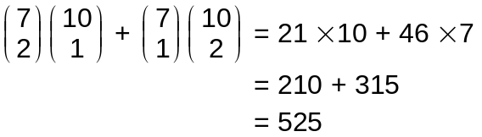



Question 13 (4 marks)
An electrical store has 10 lamps left in its storeroom. Four of the lamps have defective wiring and should not be used. A new store assistant randomly selects three of the lamps for a customer.
Let X be the number of defective lamps purchased by the customer.
Find the probability distribution for X
x | P(X=x)
0 | 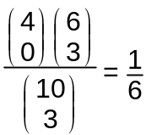  
1 | 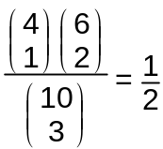  
2 | 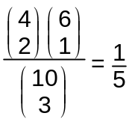  
3 | 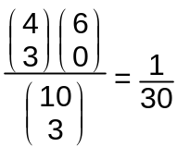  

Question 14 (7 marks)
There are 35 players in a football squad but only 28 are to be selected to form a team. Nathan and Tarquin are members of the squad. How many different teams are possible (do not simplify) if
(a) all players are available? [1]
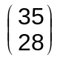

(b) Nathan must be included? [1]
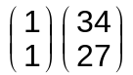

(c) Tarquin is injured and cannot play? [1]

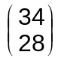

(d) Nathan will not be included but Tarquin must play? [2]
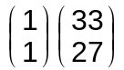



(e) Nathan and Tarquin must be included in the team? [2]
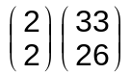


Question 15 (4 marks)
The probability density function for a continuous random variable, X, is given by the graph below.
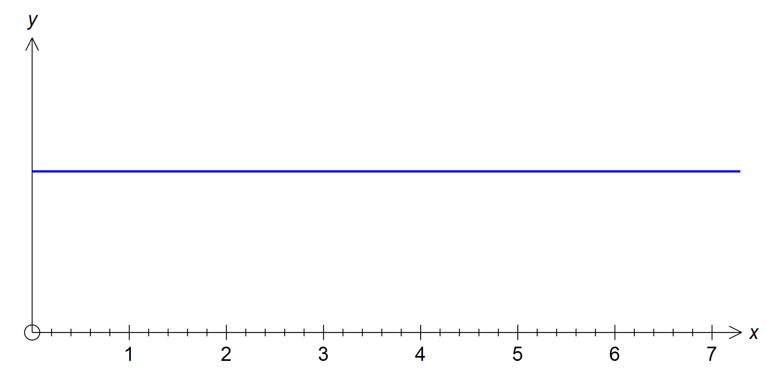
m
(a) Find the exact value of m. [1]

7m = 1
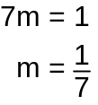


(b) Find the probability that X is less than 3. [1]
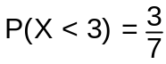


(c) Given that X is less than 3, what is the probability that X is less than 2? [2]

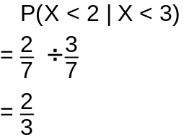


Question 16 (5 marks)
In a survey taken in a football crowd, 30% of the crowd support West Coast.
(a) Find the probability that in a random sample of 10 people:
(i) exactly 2 support West Coast. [1]
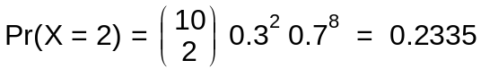


(ii) at most 4 support West Coast. [1]
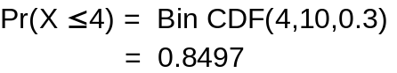


(iii) at least 3 do not support West Coast. [1]
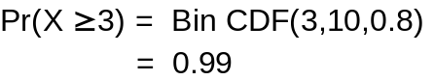


(b) What is the size of the smallest sample of people for which the probability that 3 or more support West Coast, is at least 0.2. [2]
Guess and Check



Therefore, a sample of 6 will be needed for the probability to exceed 0.2.

Question 17 (5 marks)
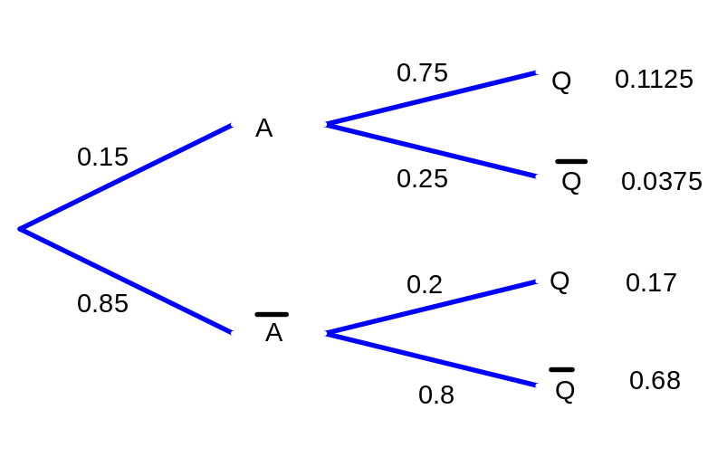In the Shakeshaft Building Company, 15% of the employees have attended a health and safety training course. Of the employees who have attended the training course, 75% are qualified to perform first aid, whereas of the employees who have not attended the training course only 20% are qualified to perform first aid.
(a) What percentage of employees in the company are not qualified to perform first aid?
[3]




% not qualified = 68% + 3.75% = 71.75%

(b) A randomly chosen employee is found to be qualified to perform first aid. What is the probability that she attended the training course? [2]

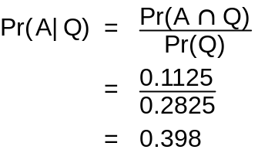



Question 18 (4 marks)
The velocity of a particle v cm/s, as it moves from rest along a straight line is given by 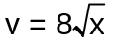 where x is its distance from the origin.
Show that if 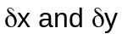 denote corresponding small increases in x and v, then
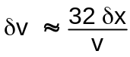
Hence find the approximate change in the velocity of the particle when x increases from 36 to 37 cm.
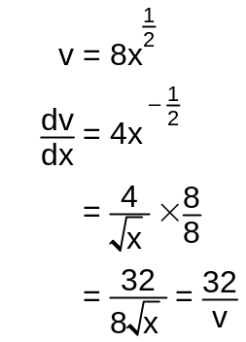


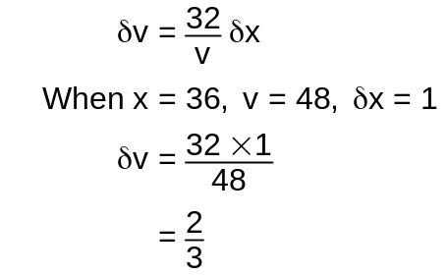


Question 19 . [ 4 marks ]
A new packing machine is being introduced into a sugar mill. It was found that the machine packs 500 gram bags of sugar with a normally distributed with a mean 514g and standard deviation 12 grams. A batch of 1000 bags was packed on a given day.
(a) How many of these bags would you expect to contain:
(i) less than 500 grams of sugar, [1]
Pr(X<500) = Norm CDF(-∞,500,12,514) = 0.1216

Therefore, 122 bags

(ii) between 500 and 520 grams? [1]
Pr(500<X<520) = 0.5697

Therefore, 570 bags
(b) Calculate the 75-percentile for the entire population. [2]

Pr(X<x) = 0.75
x = 522 from Classpad
Question 20 [8 marks] (4 marks)
An object moves along a straight line, passing through point O with a velocity of 4 m/s.
It has an acceleration, a ms⁻², given by a = 16 − 2t, t seconds after passing O.
The object comes to rest when t = k seconds.
(a) Determine the maximum velocity of the object. [2]
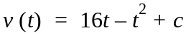
Since v (0) = 4 then c = 4 then 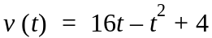 ✓
∴ Max velocity = v (8) = 68 m/s ✓

(b) Determine the exact value of k. [2]
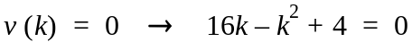 ✓
∴ 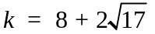 ✓

(c) Sketch the v−t graph on the axes below, showing and labelling all key points. [2]
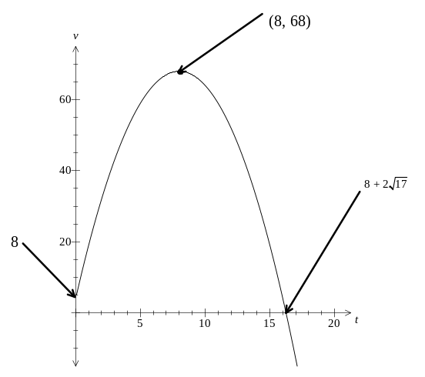




After coming to rest, the object travels for a further three seconds with a velocity
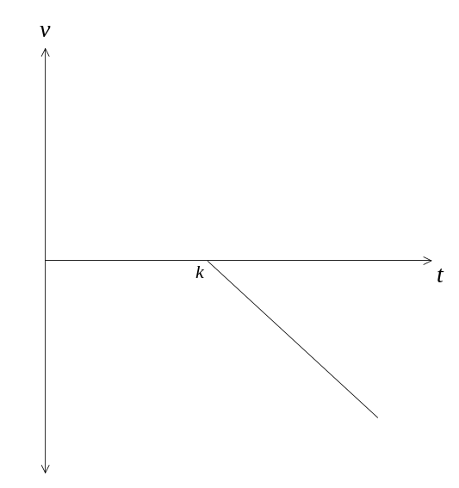 given by v = n − mt, where t > k. This is represented on the axes given below.

(d) State the expression, in terms of k, which represents the distance travelled
in that three second period. [2]

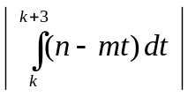



Question 21 [ 6 marks ]
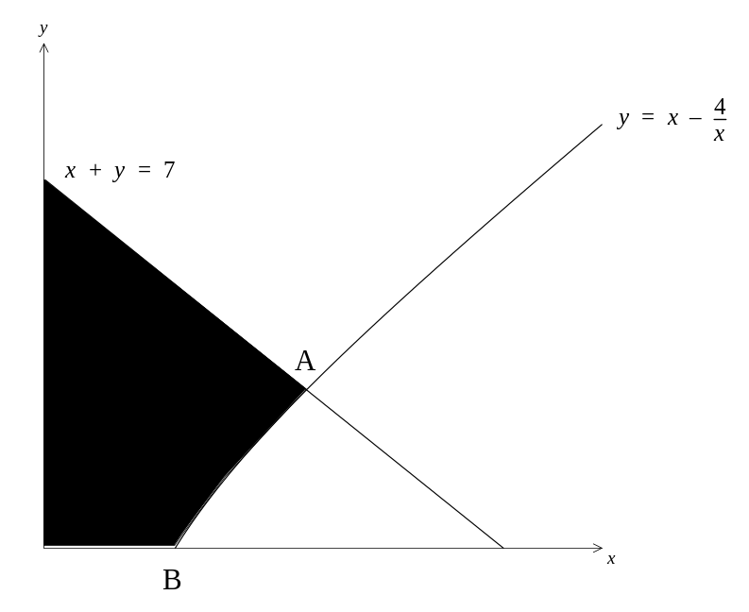

The shaded area is bounded by the x and y axes, the line x + y = 7 and the
curve with equation 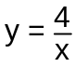 .
(a) Determine the co-ordinates of A and B. [1]

A (4, 3) and B (2, 0) ✓

(b) State an expression, which when evaluated will determine the area
of the shaded region. Give the area correct to two decimal places. [2]

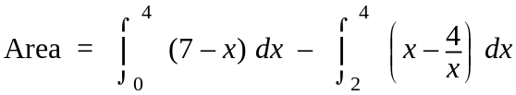 ✓✓
= 16.77 units²

(c) The shaded region is revolved 360° around the x axis.
(i) Write down the expression for the volume of the solid generated. [2]

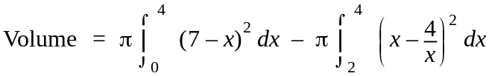 ✓✓

(ii) Determine the volume generated exactly. [1]

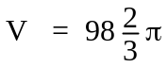 units² ✓

Question 22 [4 marks]

A population, y, increases according to the differential equation:
The population at the start of 2000 has size 1 000.
(a) State the equation for population, y, in terms of t. [1]
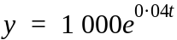


(b) State the population size when t = 5. [1]

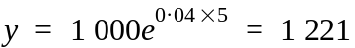

(c) Determine the doubling time for the population. [2]

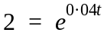

∴ t = 17.33

Question 23 [8 marks]
(a) A block of ice in the shape of a hemisphere is melting so that its total surface area diminishes at a rate of 20 cm²/h. What is the rate of change of its radius when the radius is 4 cm?
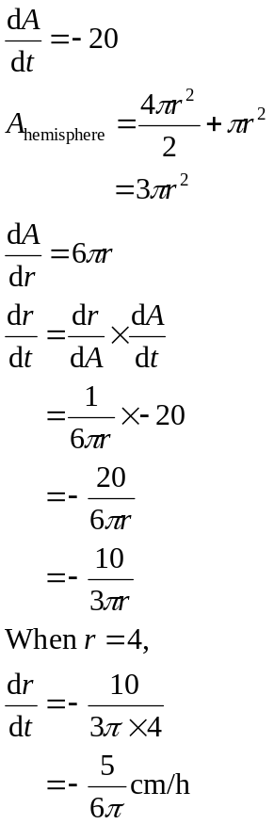 [4]




- A vase is in the shape of an inverted cone with an angle at the apex of 60°. Water is being poured into the vase at a rate of 10 mL per second. Find the rate of change of the radius of the water surface when the radius is 8 cm. [4]
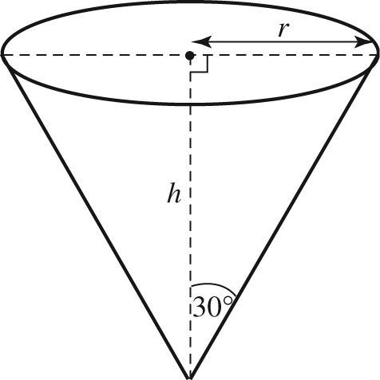
1 mL is equivalent to 1 cm³.
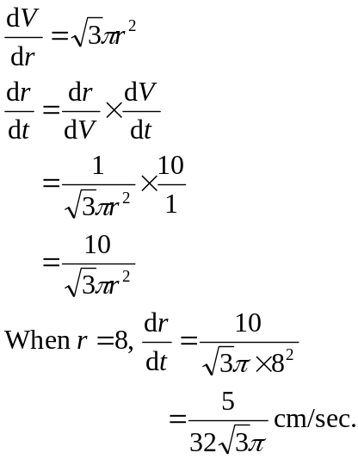
So 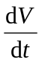 = 10 cm³/sec






